# **Department of Computer Science and Engineering Islamic University of Technology (IUT)** A subsidiary organ of OIC

# **Lab Report 04**

# CSE 4412: Data Communication and Networking Lab

## 

## **Name: Namisa Najah Raisa Student ID: 210042112 Section: B(Even) Semester: 4th(Summer) Academic Year: 2022-2023**

**Date of Submission: 17th February 2024**

### **Title:** Understanding the basics of Inter-VLAN communication using Router, L3 Switch along with basics of Static Routing

### **Objectives**:

1. Design and implement Inter-VLAN routing using Router on a stick
2. Design and implement Inter-VLAN routing using Multilayer Switch
3. Understand and implement Static Routing

### **Diagram of the experiment:**

(Provide screenshot of the final network topology. Make sure to label the network components.)

**TASK 1:**

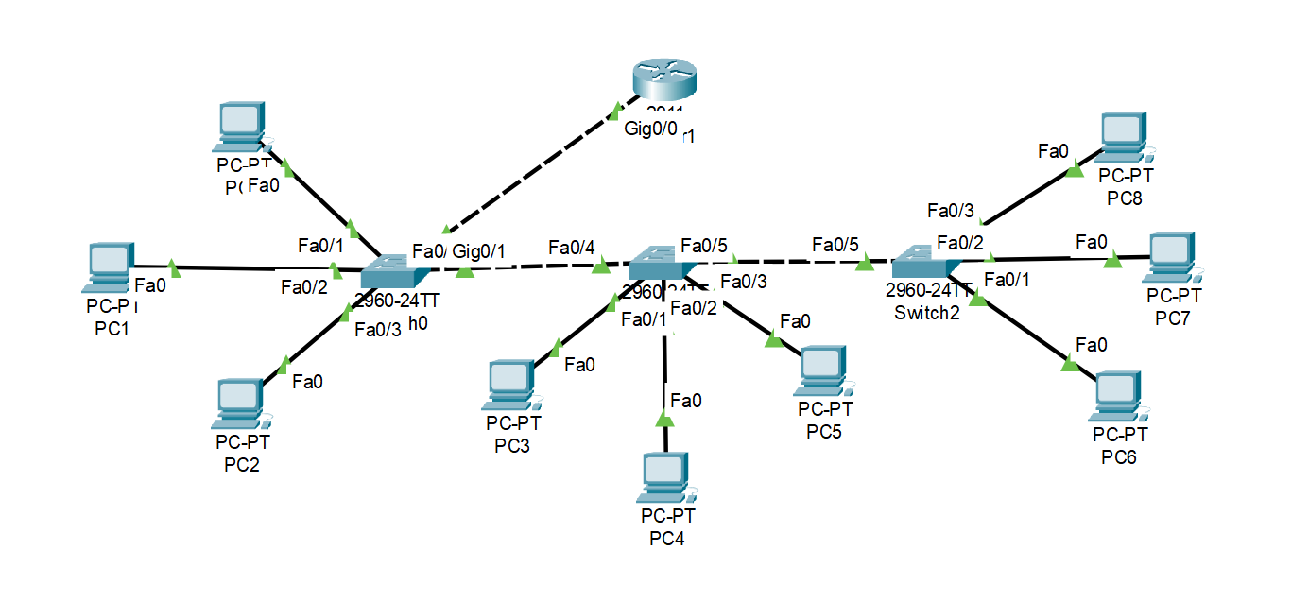

**TASK 2:**

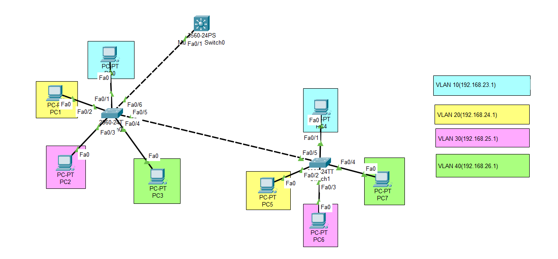

**TASK 3:**

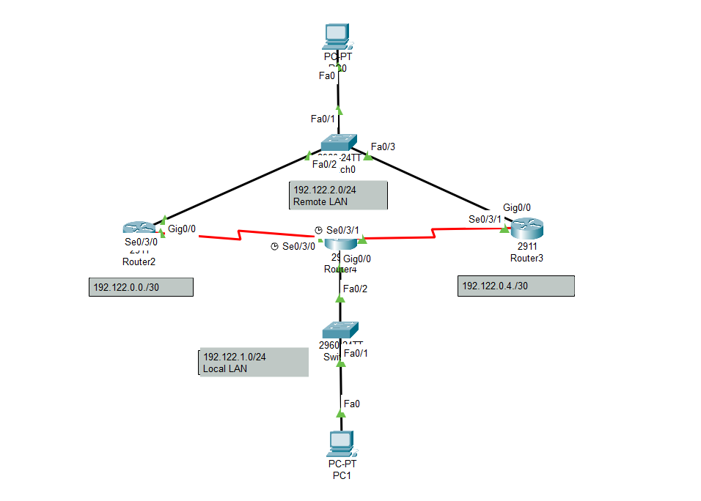

### 

### **Working Procedure:**

**(**Explain in brief how you completed the tasks. Provide necessary screenshots of used commands for each task.)

**TASK 1:**

**For the switch configurations:**

**SWITCH0:  
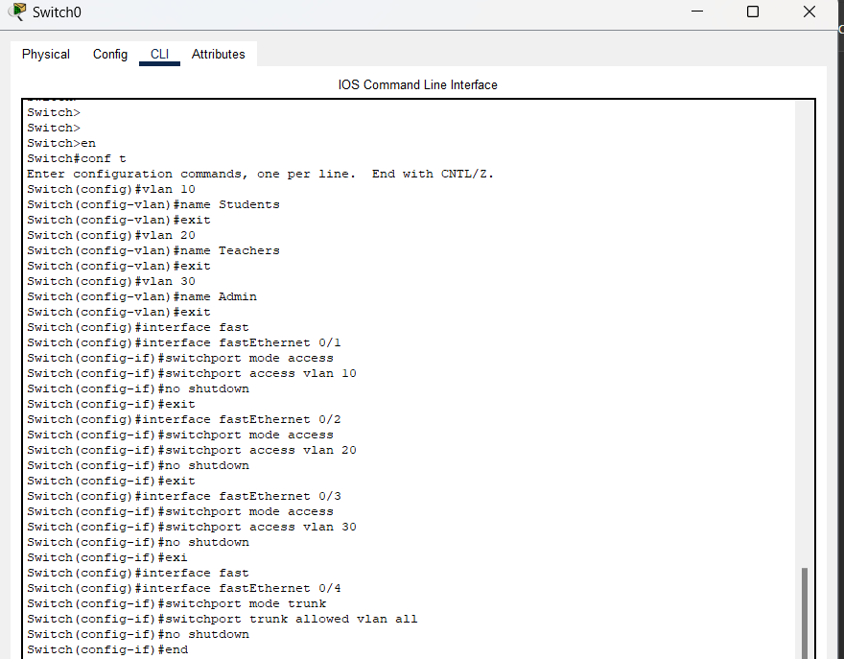**

**SWITCH1:**

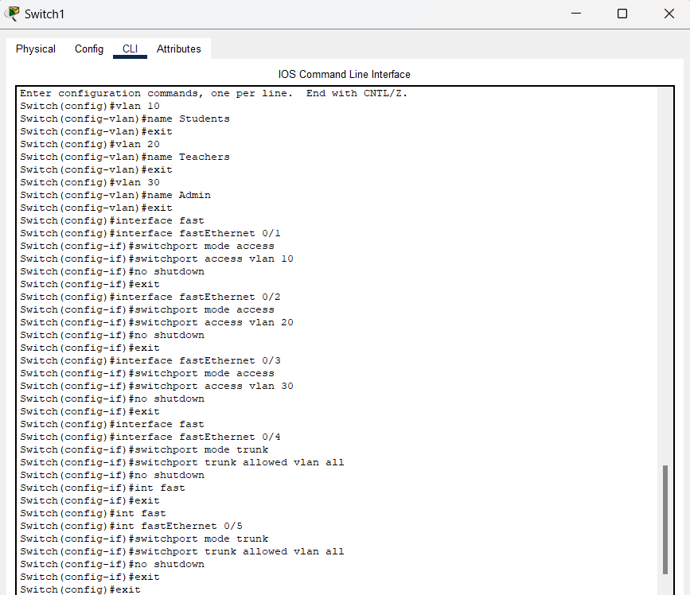

**SWITCH2:**

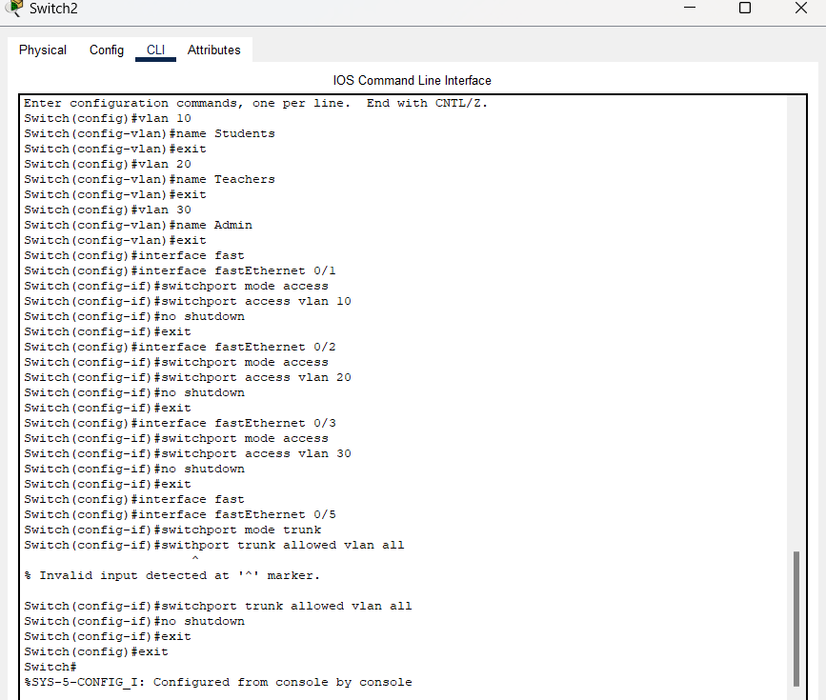

**For the router configuration:  
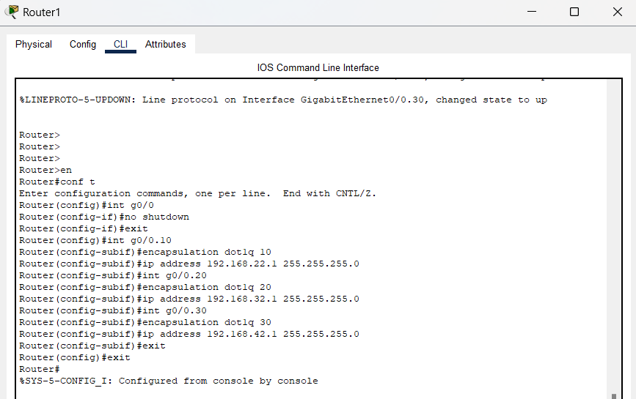**

**The PCs for VLAN 10:  
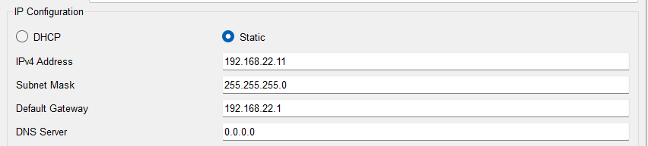**

**(The rest of the pcs of vlan 10 are configured like this as well.)**

**The PCs for VLAN 20:  
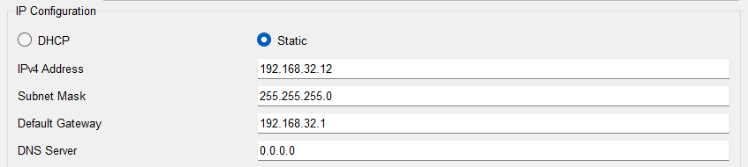**

**(The rest of the pcs of vlan 20 are configured like this as well.)**

**The PCs for VLAN 30:**

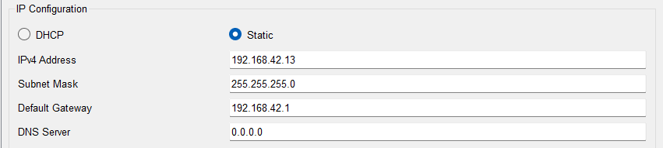

**(The rest of the pcs of vlan 30 are configured like this as well.)**

**Pinging PC from the VLAN 10 to other PC in VLAN 10 and to the PCs of the other VLANs:  
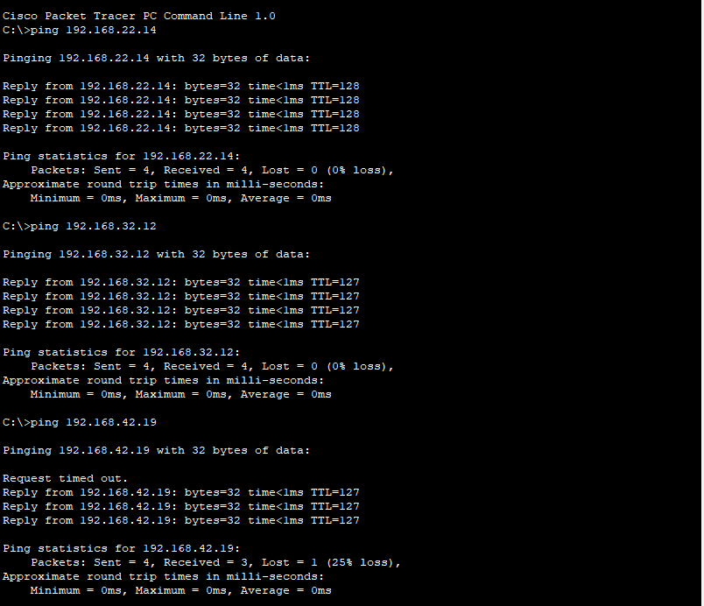**

**Pinging PC from the VLAN 20 to other PC in VLAN 20 and to the PCs of the other VLANs:  
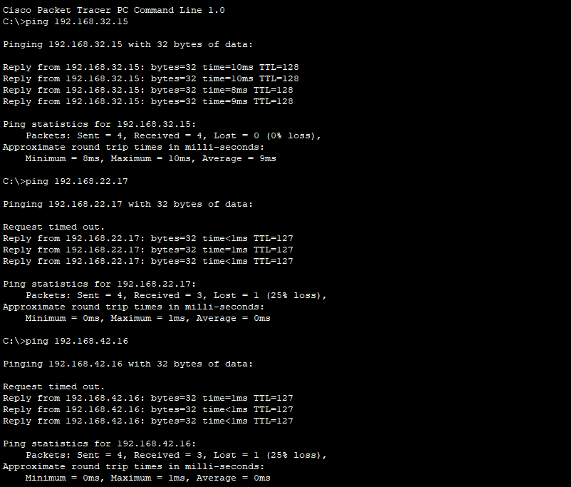**

**Pinging PC from the VLAN 30 to other PC in VLAN 30 and to the PCs of the other VLANs:  
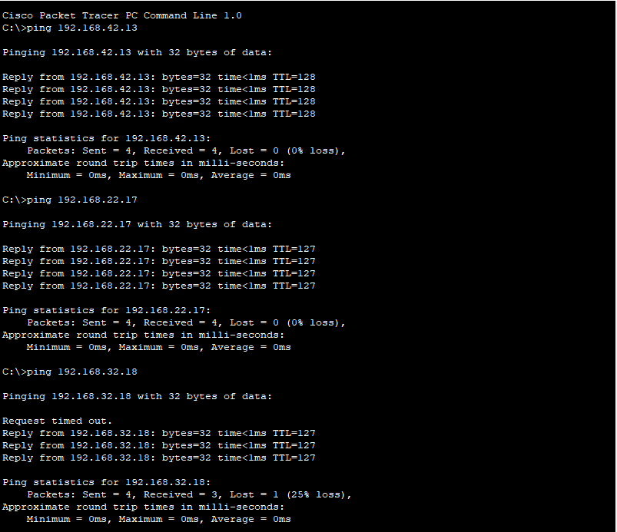**

**TASK 2:**

Configure Switch0:

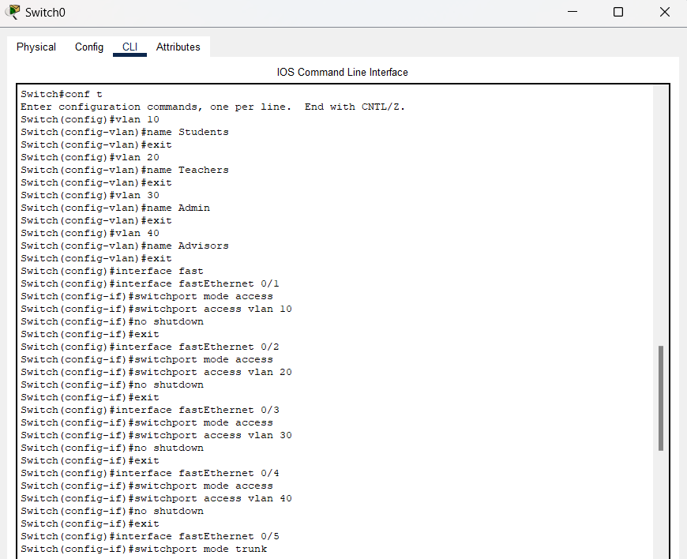

Configure Switch1:

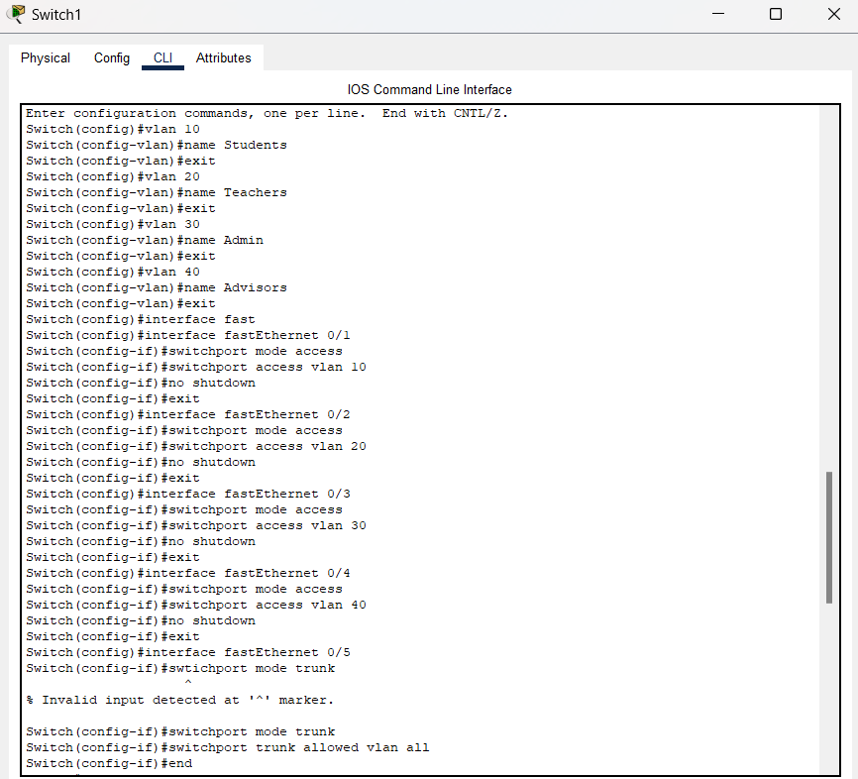

Configure the Multilayer Switch0: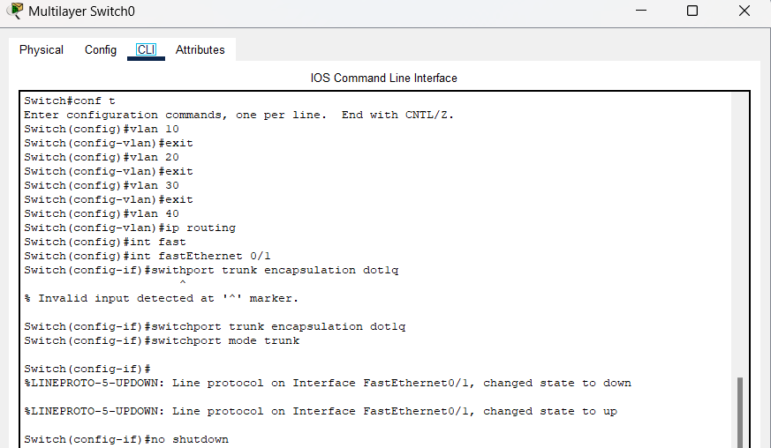

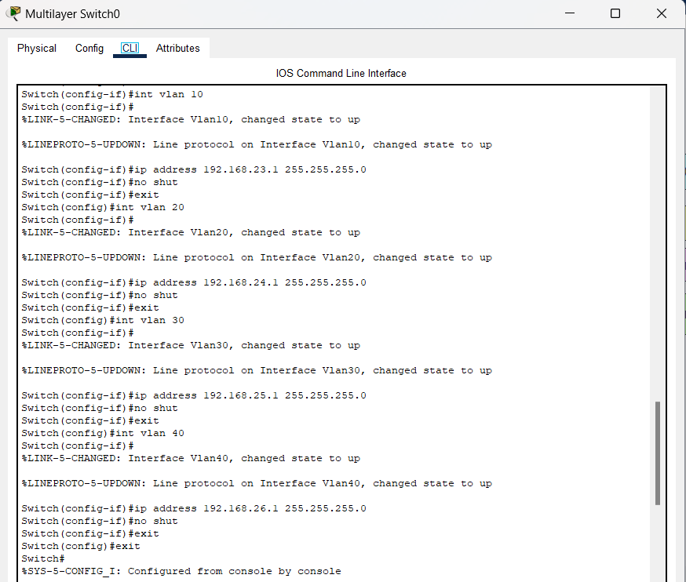

**Configure the PCs:**

VLAN 10: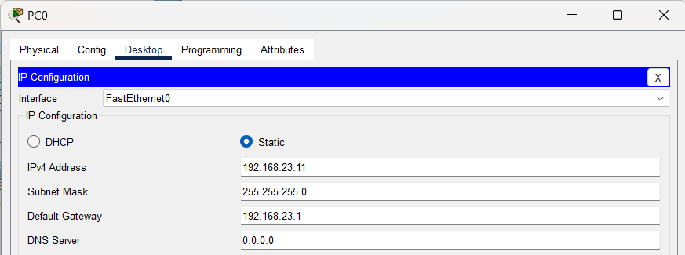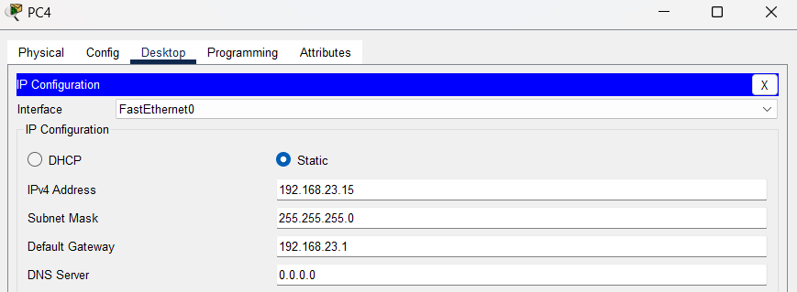

VLAN 20: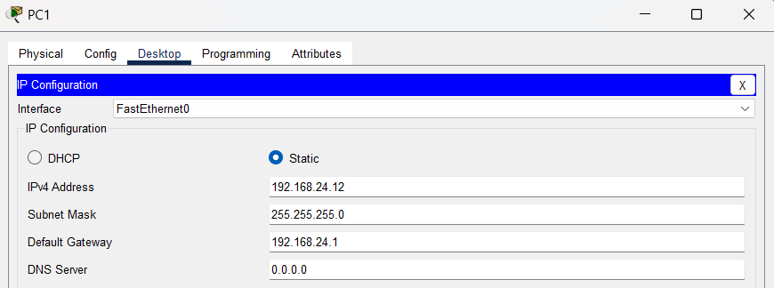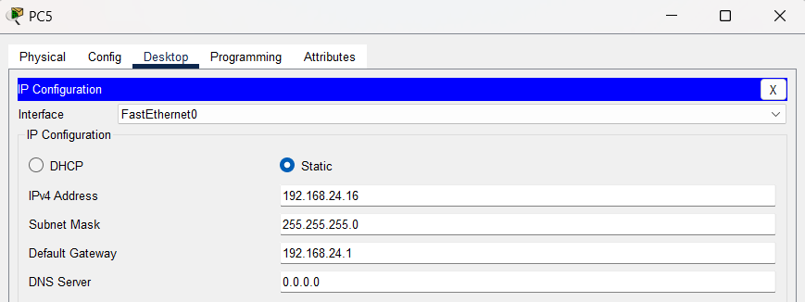

VLAN 30: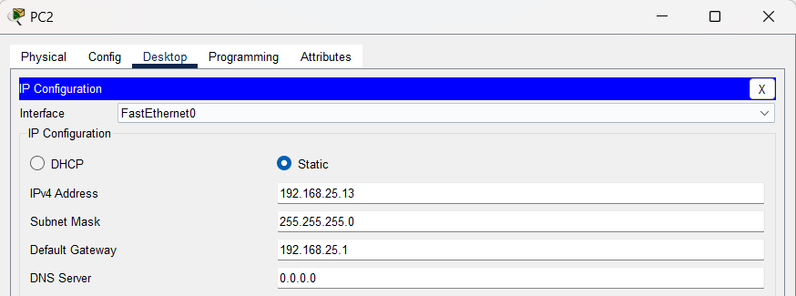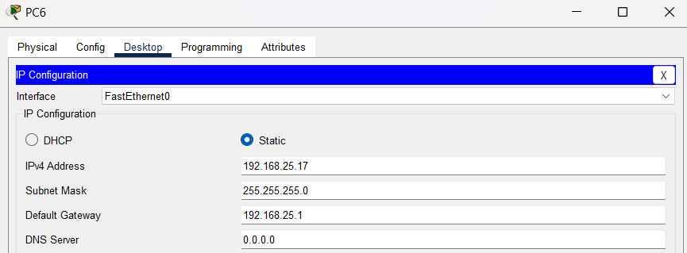

VLAN 40: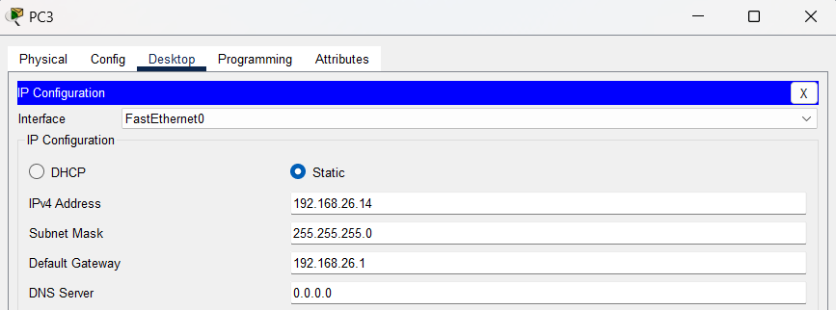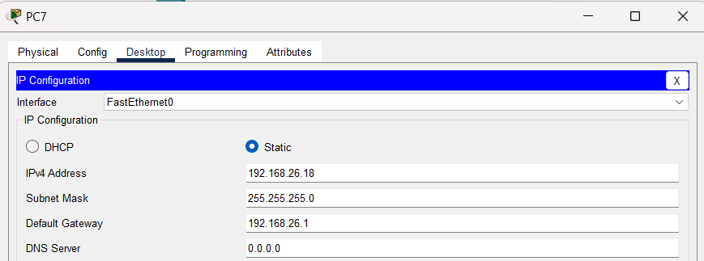

**Pinging from a VLAN 10 PC to another VLAN 10 PC and other VLAN PCs:**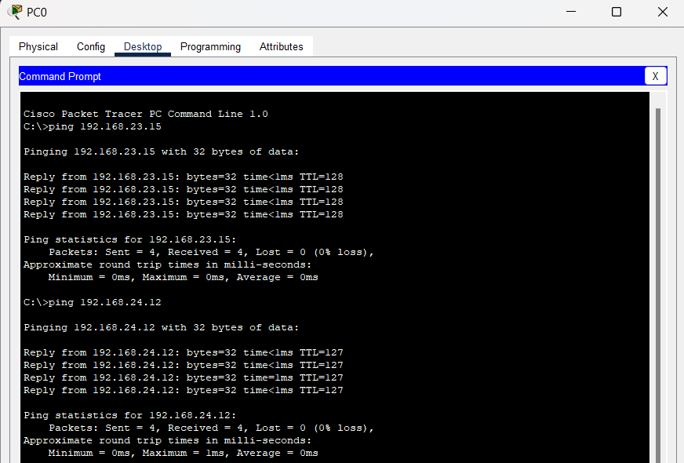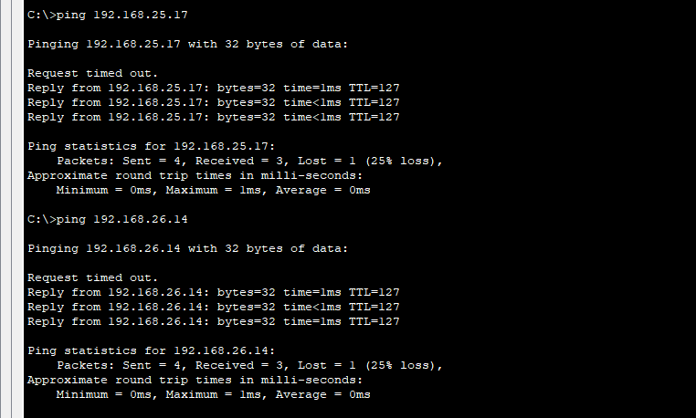

**Pinging from a VLAN 20 PC to another VLAN 20 PC and other VLAN PCs:**

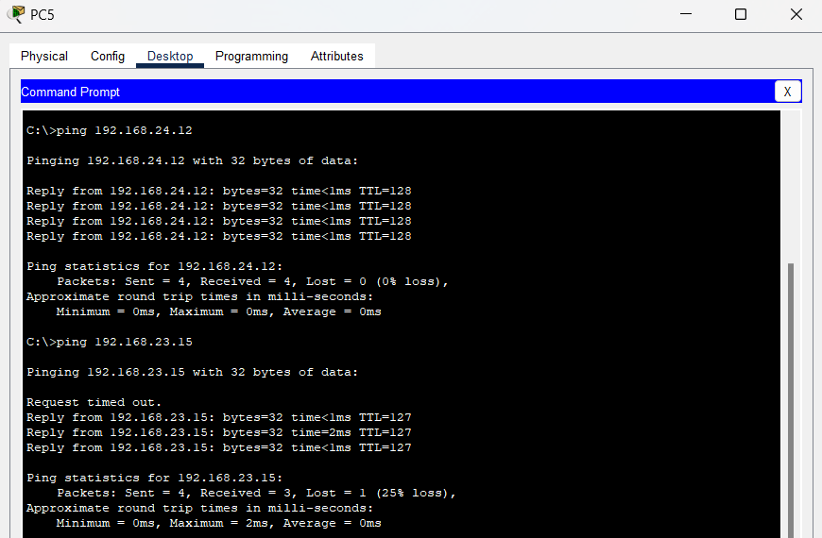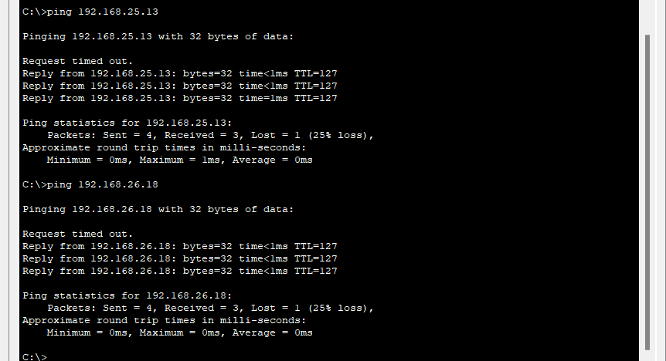

**Pinging from a VLAN 30 PC to another VLAN 30 PC and other VLAN PCs:**

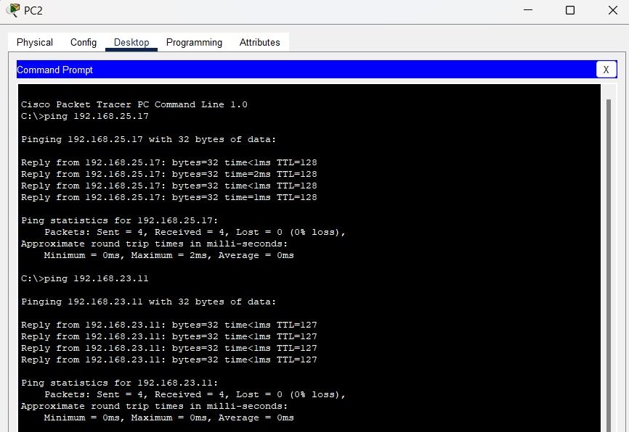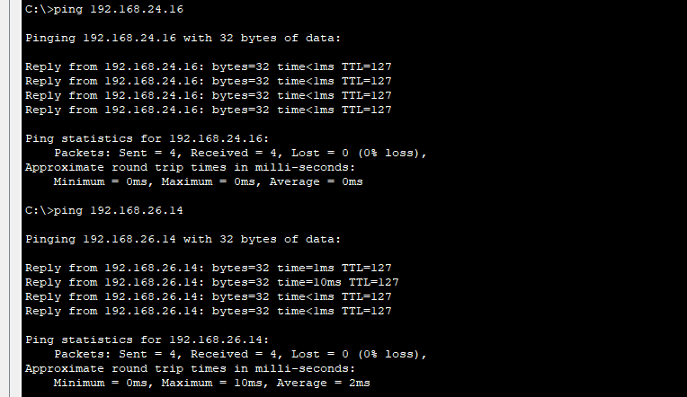

**Pinging from a VLAN 40 PC to another VLAN 40 PC and other VLAN PCs:**

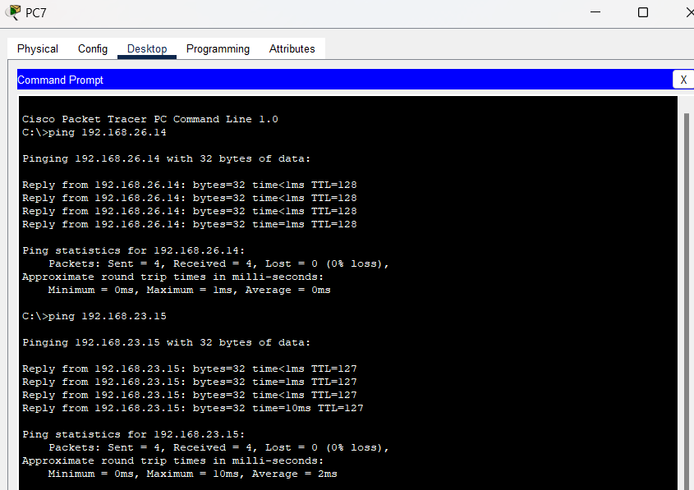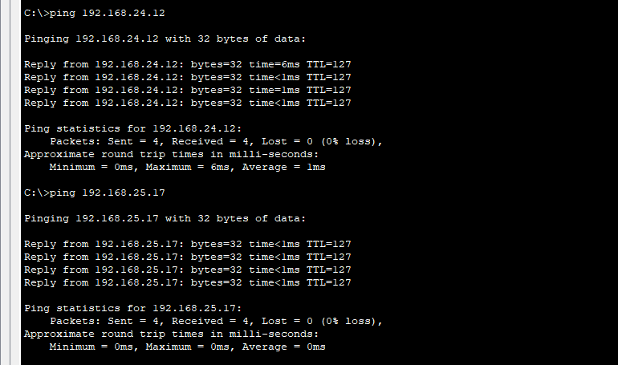

**TASK 3:**

Configure Router4 Interfaces:

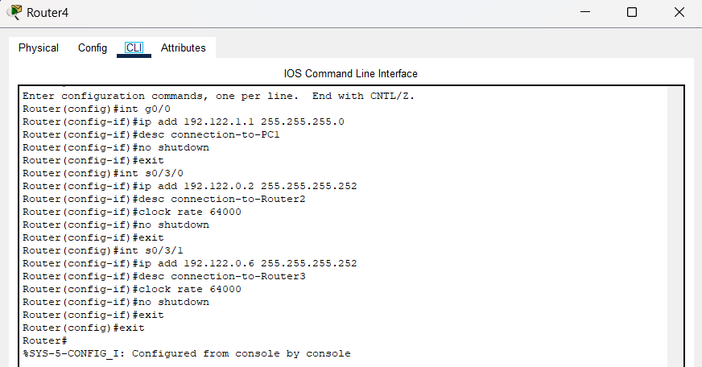

Configure Router3 Interfaces:

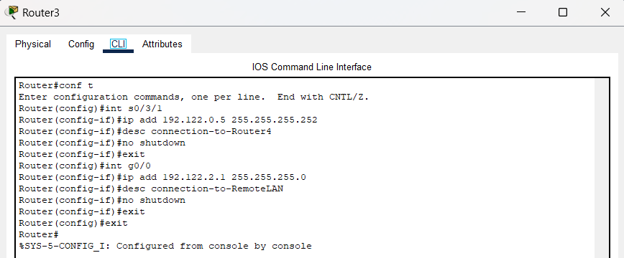

Configure Router2 Interfaces:

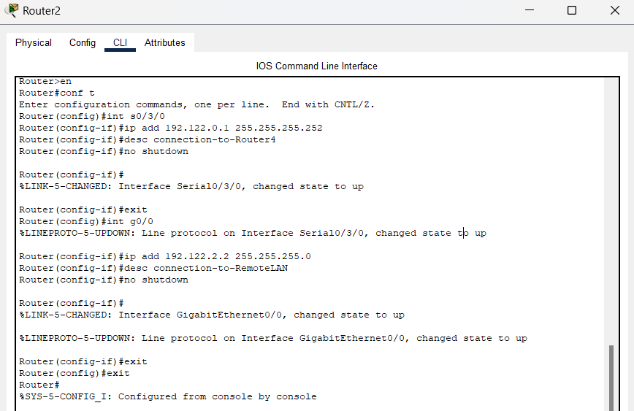

Configure PC0:

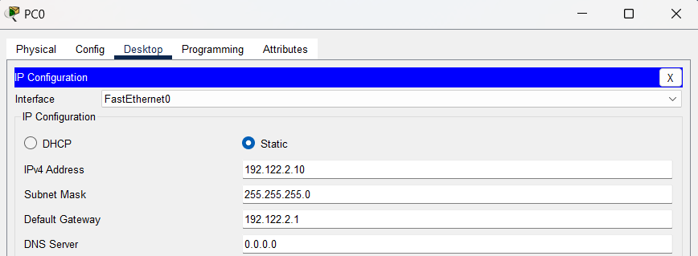

Configure PC1:

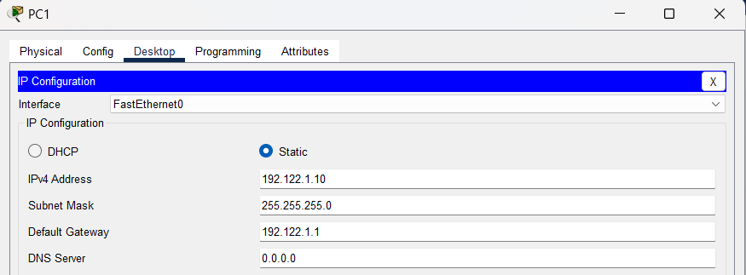

Configure static routing to Remote LAN in Router4:

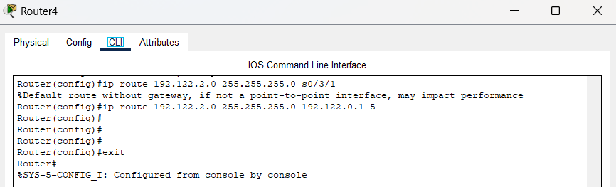

Configure static routing to Remote LAN in Router3:

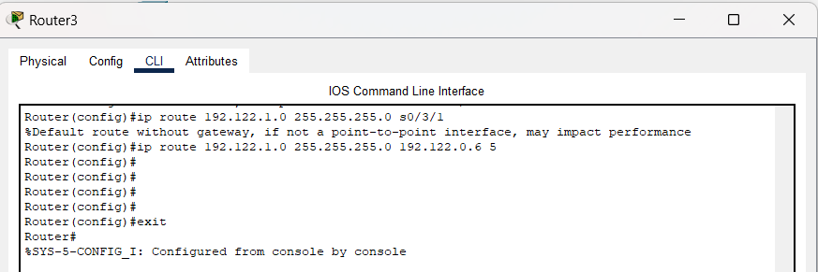

Configure static routing to Remote LAN in Router2:

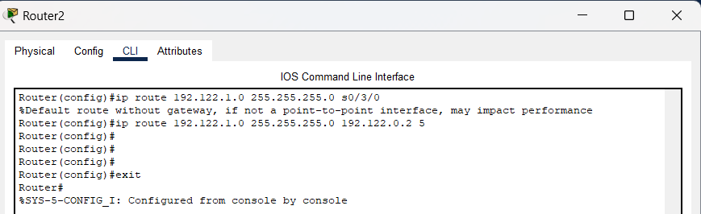

Ping PC0 from PC1:

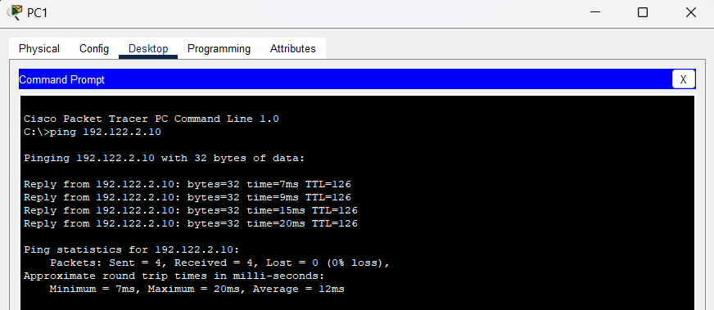

### **Questions (Answer to the point)**:

* + - 1. Why do we need L3 Switches?

**Ans:** L3 switches are needed for efficient Inter-VLAN routing. They can route traffic between VLANs at high speeds, reducing the load on external routers.

* + - 1. What is the use router in Inter-Vlan Routing?

**Ans:** Routers are used in inter-VLAN routing to allow hosts in different VLANs to communicate with each other.

* + - 1. What changes are needed while configuring VLANs using L3 switches instead of Router-on-a-stick approach?

**Ans:** When using L3 switches, there is no need for a separate router. The switch itself can perform routing between VLANs, simplifying the network architecture.

* + - 1. What is next-hop floating address?

**Ans:** The next-hop floating address is an alternate route specified in static routing with higher metric. It is used as a backup route if the primary route fails.

* + - 1. What is the disadvantage of static routing?

**Ans:** One of the drawbacks is that static routing is not flexible or resilient to changes in the network topology, as it requires manual updates and modifications. Static routing also does not support load balancing or redundancy, which can affect the performance and availability of the network.

### **Challenges (if any):**

For the Router-on-a-stick method it was kind of hard to notice that I had to trunk the router as well as it wasn’t working for the inter-VLAN.

### 